PJT12469 Automatic Preferences Communication Program Enrollment During Transfer Service

Analyst: Shajahan Kamalbatcha

History of Changes

Rev. | Date | Modified by | Comments
0.1 | 01/17/2017 | Shajahan Kamalbatcha | Initial Draft
1 | 02-02-2017 | Shajahan Kamalbatcha | CRM changes updated

Overview

The purpose of this document is to outline the process related automatic enrollment of customer communication preference programs during transfers service process for Contract account that has existing enrollment.
It also outline the process related to de-enrollment of preference program when service gets reversed.

Success Criteria

Customer will receive all applicable notifications to their preferred communication methods that were previously enrolled in another account. This is applicable for move-in account that has created/reused as part of transfer.

Customer will not receive alert notifications if the service gets canceled either by system or by customer request.

Business Requirement:

- System should automatically enroll contract account into eligible preference programs during transfers (Move-out and Move-in requested in one instant or simultaneously).
- Moved-out contract account must have enrolled in one or more preference center program
  - eBill
  - Billing and Outage alerts
  - Payment Preference
- Move-in contract account can be either new or existing one
- Enrollment of move-in accounts should follow existing eligibility rules
- Applicable to all account classes

- CSR start contract should display pre-selected preference communication program acceptance if contract account from end contract on same date has existing enrollment.
  - User should have option to unselect if customer wants to opt-out

- System should automatically de-enroll from preferences program when service gets cancelled or reversed by customer request or by system process (such as move-in reversal failure to provide ID for FACTA failure or other reasons)

Functional/Technical Requirement:

- Enhance move-in workflow to process copy preference programs (Workflow)
- New Webservices for copy preference programs (PI)
- New Enhancement to support copy preference programs (ECC ABAP)
- New Enhancement to CRM start contract (CRM ABAP)
- Enhance Z2WCC_CUST_PREF_BATCH_SYNC to include move-in reversal

Solution Design Summary:

Process Flow:

Copy Preference Program Subscription

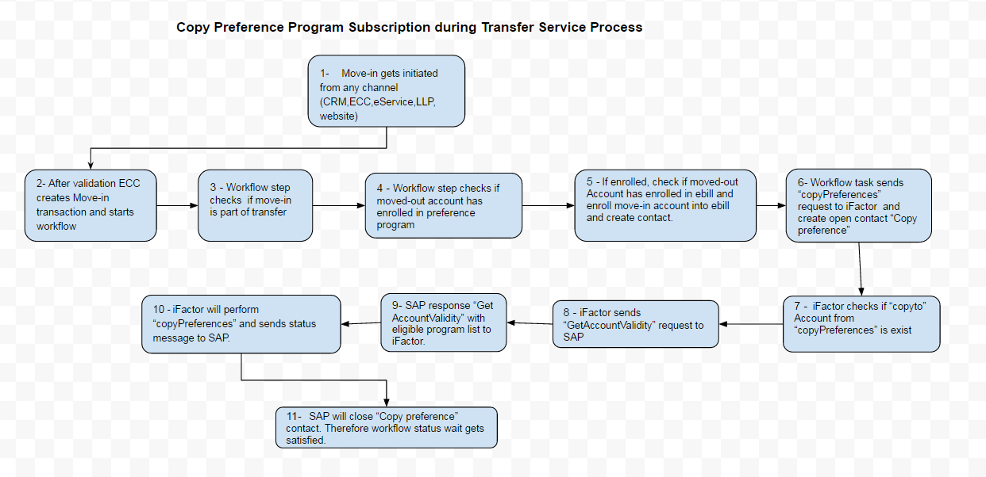

- Process starts when Move-in gets initiated from any channel (CRM, eService, Landlord portal, CE website)

- After validation of move-in request from multiple channel SAP ECC creates Move-in transaction and starts workflow

- Workflow step checks if move-in is part of transfer (Transfer represents move-out and move-in requested on same system date for same customer)

- Workflow step checks if moved-out account has enrolled in preference programs.

- If enrolled, system checks if moved-out Account has enrolled in ebill and enroll move-in account into ebill if confirmed and create ebill enroll contact.

- Workflow task sends “copyPreferences” webservice request to iFactor and create BP contact “Copy preference” with status open.

- iFactor checks if “copyto” Account number from “copyPreserences” is exist.

- iFactor sends “GetAccountValidity” request to SAP for both existing and non-existing account in their system.

- SAP response “Get AccountValidity” with eligible program list to iFactor.
      - Example: - <Eligible>
      - <Code>OUTAGE</Code>
      - <Code>BILLING_PAYMENT_EMAIL</Code>
      - <Code>REQUIRED_BILLING</Code>
      - <Code>BILLING_PAYMENT_VOICE</Code>
      - <Code>BILLING_PAYMENT_SMS</Code>
      - <Code>EBILL</Code>
        - </Eligible>

- iFactor will perform “copyPreferences” and sends status message to SAP.

- Upon successful status, SAP will close “Copy preference” BP contact. Therefore workflow status wait gets satisfied.

Unsubscribe Preferences Programs after Move-in reversal/Cancel

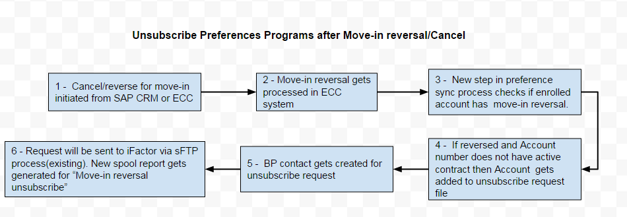

- Cancel/reverse for move-in initiated from SAP CRM or ECC

- Move-in reversal gets processed in ECC system

- New step in preference sync process checks if enrolled account has move-in reversal.

- If reversed and Account number does not have active contract then Account gets added to unsubscribe request file

- BP contact gets created for unsubscribe request

- Request will be sent to iFactor via sFTP process (existing). New spool report gets generated for “Move-in reversal unsubscribe”

Functional Solution

Solution Requirement 1

Modify move-in workflow to process copy preference programs (Workflow)

When customer has requested transfer of their electric and/or gas service from their current service address to new service address, it consists of two requests. One is move-out/end contract from current service and second is move-in/start contract to new location. During the process customer have options to choose current date or future date for their request via eServices or CE website MIMO applications. Similarly Landlords makes their request via landlord portal application, CSR makes request via CRM UI application and sometime other internal CE team creates such request with in SAP ECC application. For simplicity, we are considering same creation date as limiting factor to determine transfer service.

Regardless of where it has been originated, all transfer requests are finally gets processed at SAP ECC system. Wherein after successful error check, Move-out and Move-in transactions get created accordingly. Each transaction has its own workflow to timely trigger and monitors various activities in the process. This section covers additional changes being included in Move-in workflow to perform automatic customer preference programs enrollment if the moved-out account has already enrolled in such programs.

Following changes are applicable to workflow WS93000115 and WS93100281

- Transfer check – new task will be included to check if move-out has created on same date as move-in for same business partner. Transfer step will be passed if EEIN-ZPREF = space and move-out exist.

Entire auto enrollment process workflow steps will be skipped
- If move-out exist but with reversal flag on same creation date as move-in
- If no move-out exist on same creation date as move-in
- If EEIN-ZPREF <> Space

Table references:
EEIN-ERDAT = EAUS-ERDAT
EEIN-KUNDE = EAUS-KUNDE
EAUS-STORAUSZ <> X
EEIN-STORAUSZ <> X
EEIN-ZPREF

- Existing preference enrollment check – new task will be included and gets triggered if transfer fag is set from transfer check step. This task will check if contract account from move-in record exists in preference table (ZT2WCC_CUSTPREFA and ZT2WCC_CUSTPREFB). If exist then whole process of automatic preference enrollment will be skipped. If not exist then check if moved-out accounts that were extracted from previous step exists and skip if it doesn’t exist.

- Ebill enrollment - If moved-out account exists in preference table (Existing preference enrollment check has passed) then add a task to check for ebill enrollment. If enrolled then perform ebill enroll move-in contract account.

Table reference:
FKKVKP-VKONT = moved-out contract account number
FKKVKP- EMAIL_FIS = X

Object: ZII_SI_BUSINESS_PARTNER_IN~UPDATE_BPMAILING_OPTION
Function Module: Z_ESERVICES_UPDATE_MAILING

- Copy Preference request – new task will be added to trigger webservice call “copyPreferences” if “Existing preference enrollment check” has passed and/or “Ebill enrollment” has passed. New BP contact will be created and set as open status.
Class = ZCUS
Activity = CPREF
Long Text = “Customer Preferences copied from (move-out CA) to (move-in)”

- Close CPREF contact – new wait step will be added to check the status of CPREF contact to trigger next step of move-in workflow. Contact will be close once SAP received success status message from iFactor.

Solution Requirement 2

Create new services for copy preference programs (PI)

New services will be created to process automatic enrollment during transfer service process.

- “copyPreference” request webservice will be created based on references given by iFactor. This request will be triggered from move-in workflow for qualified transfer service request.

- “copyPreference” response webservice will be created to receive status from iFactor. This service will check the status (“S”) and close BP contact “CPREF” which will completes workflow step.

- Upon receiving “copyPreference” request, iFactor will validate if both copy from and to accounts exist in their system. If “copyto” account is exist, it will send status message as “A” (already exist). If not exist then it will send “GetAccountValidity” request to SAP PI.

- SAP PI will send “GetAccountValidity” response with eligible list of programs. iFactor will completes copy preferences and send status message “S” or “E” or “A” to SAP PI

S = Success
E = Error
A = Already exist

Existing webservice sample:

iFactor - GetAccountValidityRequest

<?xml version="1.0" encoding="UTF-8" ?>
- <ns0:MT_GetAccountValidityRequest xmlns:ns0="http://ce.corp.com/xi/2WCC/InteractiveMessages">
- <ValidateAccount>
<AccountNumber>100000129468</AccountNumber>
</ValidateAccount>
</ns0:MT_GetAccountValidityRequest>

SAP- GetAccountValidityResponse

- <ValidityResponse>
<AccountNumber>100000129468</AccountNumber>
- <Eligible>
<Code>OUTAGE</Code>
<Code>BILLING_PAYMENT_EMAIL</Code>
<Code>REQUIRED_BILLING</Code>
<Code>BILLING_PAYMENT_VOICE</Code>
<Code>BILLING_PAYMENT_SMS</Code>
<Code>EBILL</Code>
</Eligible>
<Status>ACTIVE</Status>
<ShortAddress>42000 SEVEN MILE RD</ShortAddress>
<LongAddress>42000 SEVEN MILE RD NORTHVILLE MI 48167-9815</LongAddress>
<County>WAYNE COUNTY</County>
<CompanyName>Consumers Energy</CompanyName>
<ElectricMeterId>7002885817</ElectricMeterId>
<Email>skamalbatcha@cmsenergy.com</Email>
<ClassificationCode />
<AuthCode>42000</AuthCode>
<BusinessPartner>1000437773</BusinessPartner>
</ValidityResponse>
</n0:MT_GetAccountValidityResponse>

CopyPreferences Method document provided by iFactor:

copyPreferences Method

Copy all of the preferences (contacts, registrations, and settings) from one account to another. This operation will leave the fromAccount intact with all of its preferences. If Notifi does not know about the destination account number provided, it will make a call to the Utility AccountValidation Service's validateAccount() method to retrieve and persist details for that account in Notifi.

copyPreferences Request Example

<soapenv:Envelope xmlns:soapenv="http://schemas.xmlsoap.org/soap/envelope/" xmlns:prof="http://notifi.ifactorconsulting.com/soap/v4/profile">
<soapenv:Header/>
<soapenv:Body>
<prof:copyPreferences>
<fromAccount number="999999999"/>
<toAccount number="999999991" />
</prof:copyPreferences>
</soapenv:Body>
</soapenv:Envelope>

copyPreferences Request Parameters

Attribute Required Description

Attribute | Required | Description
<fromAccount number= > | Yes | String : the source account number
<fromAccount qualifier= | No | String : an additional qualifier that can be added to the source account to ensure uniqueness across all
<toAccount number= > | Yes | Yes String : the destination account number
<toAccount qualifier= > | No | String : an additional qualifier that can be added to the destination account to ensure uniqueness  across all subsidiaries within the organization

copyPreferences Response Example

A successful response from the web method will return the following object.

<S:Envelope xmlns:S="http://schemas.xmlsoap.org/soap/envelope/">
<S:Body>
<ns2:copyPreferencesResponse xmlns:ns2="http://notifi.ifactorconsulting.com/soap/v4/profile"/>
</S:Body>
</S:Envelope>

Solution Requirement 3

Create new objects to support copy preference programs (ECC ABAP)

Transfer check

For every move-in, workflow will trigger transfer check. New object will be created to check Move-in table field EEIN-ZPREF.
If EEIN-ZPREF = N then set skip flag to workflow.
If EEIN-ZPREF = space then check if move-out got created (creation date) on same date as move-in. If move-out has not reversed, transfer confirmation flag will be created. If BP has more than one moveout exist on that date then multiple contract accounts will be passed to next step of workflow.
If EEIN-ZPREF = space and there was not move-out created then set skip flag to work flow.

Table references:
EEIN-ERDAT = EAUS-ERDAT (create date)
EEIN-KUNDE = EAUS-KUNDE (Business partner)
EAUS-STORAUSZ <> X (reversal flag)
EEIN-STORAUSZ <> X (reversal flag)

Existing preference enrollment check

Transfer check object will pass one or more move-out contract accounts and single move-in account number as input. New enhancement will check if move-in contract account number exists in preference table which is getting feed from iFactor on nightly basis. There are chances that new preferences enrollments or changes made after nightly feed won’t be exist in SAP. If move-in account number exists in preference table, then empty output account list will be passed. If not check if move-out contract account(s) exists. Qualified move-out account number list will passed to workflow.

If moved-out Account has no enrollment then set skip flag to workflow

Table References:
ZT2WCC_CUSTPREFA
ZT2WCC_CUSTPREFB

ebill enrollment

Enhancement will check if each qualified moved-out account for “existing preference enrollment check” has enrolled in ebill. If one of the accounts enrolled in ebill then move-in account will be enrolled in ebill using existing function module referenced below.

Table reference:
FKKVKP-VKONT = moved-out contract account number
FKKVKP- EMAIL_FIS = X

Object: ZII_SI_BUSINESS_PARTNER_IN~UPDATE_BPMAILING_OPTION
Function Module: Z_ESERVICES_UPDATE_MAILING

Copy Preference request

- Enhancement checks the output list from “Existing preference enrollment check” and qualify “From Account Number” contract account based on following conditions. This enhancement will be utilized by “copyPreferences” webservice.

- If more than one move-out contract accounts exist, filter the list by Account class or Account determination matching with move-in contract account

Move-out | Move-in | Qualified
Res | RES | Yes
COM | COM | Yes
IND | IND | Yes
RES | COM | NO
RES | IND | NO
COM | RES | NO
COM | IND | NO
IND | RES | NO
IND | COM | NO

- If more than one move-out contract account exists then filters by contract type.

Move-out | Move-in | Qualified
Combo | Combo | Yes
Electric | Electric | Yes
Gas | Gas | Yes
Electric | Gas | No
Electric | Combo | Yes
Gas | Electric | Yes
Gas | Combo | Yes

- If more than one account gets qualified after above two filters, one of the accounts will be selected for “From Account number”. Move-in Account number will be passed as “To Account Number”

- New BP contact will be created and set as open status.
Class = ZCUS
Activity = CPREF (Copy Preference)
Long Text = “Customer Preferences copied from (move-out CA) to (move-in CA)”

Close CPREF contact

New Enhancement will be created to close BP contact when SAP receives status update from iFactor.

- If Status = “S” then BP contact will be closed.

- If Status = “E” then ZCUS/CPREF contact will be closed and created new BP contact
Class = ZCUS
Activity = FPREF(copy preference filed)
Long Text = “Copy Customer Preferences request from (move-out CA) to (move-in CA) has been Failed”

- If Status = “A” then ZCUS/CPREF contact will be closed and created new BP contact
Class = ZCUS
Activity = FPREF(copy preference filed)
Long Text = “Customer Preferences for (move-in CA) already exist”

ECC support code for CRM Opt-in:

- When ECC receives auto enroll eligibility check from CRM, new function module will check move-in account with below two conditions and send eligibility flag and Move-out contract number back to CRM.

- Check if Move-in business partner has already requested a move-out on same date. Transfer check enhancement for workflow will be utilized here.

- Check if Moved-out Contract account has already enrolled in preference communication program. Existing preference Enrollment check enhancement for workflow will be utilized here.

- When ECC receives Opt-out flag from CRM, New function module will set “N” to Move-in table (EEIN) field ZPREF. New Zfield (ZPREF) will be added to EEIN table.

Solution Requirement 4

New Enhancement to CRM start contract (CRM ABAP)

- After start contract submission gets processed, email address confirmation screen is currently displayed in CRM UI. Minor enhancement will be made to display in-screen or pop-up message with pre-selected option of automatic enrollment of preference communication programs. This message will be displayed if business partner from start contract has already requested an end contract on same date and that contact account has already enrolled in preference communication program. Refer ECC ABAP section for backend enhancement. Eligibility flag and Move-out Contract account numbers will be received from ECC.

- Mock-up message:
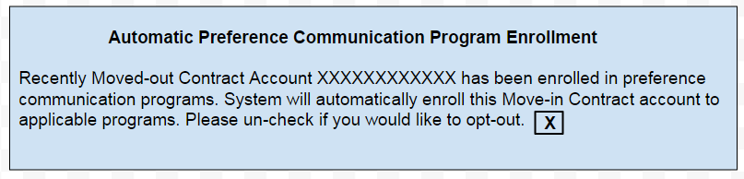

- When user unchecked selection box, new enhancement will send opt-out flag (ZPREF) to ECC.

Note: Refer ECC support code for CRM Opt-in for backend enhancement

Solution Requirement 5

Enhance Z2WCC_CUST_PREF_BATCH_SYNC to include move-in reversal

- Z2WCC_CUST_PRED_BATCH_SYNC report program has logic exist to create preference program unsubscribe request for contract account that has been final billed and past 45 days of move-out date. This program will be modified to generate unsubscribe request for contract account that has existing preference program subscription with iFactor and has recent move-in reversal/cancel and no active energy contract exist.
- Existing preference program subscriptions will be validated against table ZT2WCC_CUSTPREFA and ZT2WCC_CUSTPREFB
- New report header “Number unsubscribed due to move-in reversal:” will be added to existing spool output.

- New unsubscribe reason “Move-in reversed” will be added to following spool reports
  - “iFactor Unsubscribe Successful”
  - “iFactor Unsubscribe Failed”

Reference Report Programs:
Z2WCC_CUST_PRED_BATCH_SYNC
Z2WCC_CUST_PREF_BATCH_SYNC_CH
Table Reference
EVER
EEIN
ZT2WCC_CUSTPREFA
ZT2WCC_CUSTPREFB

- Performance Requirements:
NA

- Security Requirements:
NA

- Reliability Requirements:
N/A

- Compatibility Requirements:
NA

- Usability Requirements:
NA

- Maintainability Requirements:
N/A

- Transferability Requirements:
N/A
- Hardware Requirements:
N/A

- Software Requirements:
N/A

- Batch job Requirements:
N/A

Testing Considerations

Interface between iFactor and SAP PI should be working
RFC connection between ECC and CRM system should be working.
Interface from eService to SAP should be working
Interface from Landlord portal to SAP should be working
Interface from CE website to SAP should be working

Test Scenarios:

Test Scenario | Expected Result
New move-in via eService and enroll in preference program | Successful Perf Prog Enrollment
New move-in via CRM and enroll in preference program via CRM | Successful Perf Prog Enrollment
New move-in via ECC and enroll in preference program via eService | Successful Perf Prog Enrollment
New move-in via LLP and enroll in preference program via eService | Successful Perf Prog Enrollment
New move-in via MIMO website and enroll in preference program via eService | Successful Perf Prog Enrollment
Enroll in preference program for existing energy account | Successful Perf Prog Enrollment
New move-in via CRM and enroll in preference program via eService | Successful Perf Prog Enrollment
New move-in via ECC and enroll in preference program via CRM | Successful Perf Prog Enrollment
New move-in via LLP and enroll in preference program via CRM | Successful Perf Prog Enrollment
New move-in via MIMO website and enroll in preference program CRM | Successful Perf Prog Enrollment
Res Elec Transfer Service via eService (Move-out Account should have enrolled in Pref pgm) | Successful Perf Prog Enrollment
Res Elec Transfer Service via CRM (Move-out Account should have enrolled in Pref pgm) | Successful Perf Prog Enrollment
Res Elec Transfer Service via LLP (Move-out Account should have enrolled in Pref pgm) | Successful Perf Prog Enrollment
Res Elec Transfer Service via ECC(Move-out Account should have enrolled in Pref pgm) | Successful Perf Prog Enrollment
Res Gas Transfer Service via eService (Move-out Account should have enrolled in Pref pgm) | Successful Perf Prog Enrollment
Res Gas Transfer Service via CRM (Move-out Account should have enrolled in Pref pgm) | Successful Perf Prog Enrollment
Res Gas Transfer Service via LLP (Move-out Account should have enrolled in Pref pgm) | Successful Perf Prog Enrollment
Res Gas Transfer Service via ECC(Move-out Account should have enrolled in Pref pgm) | Successful Perf Prog Enrollment
Res Combo Transfer Service via eService (Move-out Account should have enrolled in Pref pgm) | Successful Perf Prog Enrollment
Res Combo Transfer Service via CRM (Move-out Account should have enrolled in Pref pgm) | Successful Perf Prog Enrollment
Res Combo Transfer Service via LLP (Move-out Account should have enrolled in Pref pgm) | Successful Perf Prog Enrollment
Res Combo Transfer Service via ECC(Move-out Account should have enrolled in Pref pgm) | Successful Perf Prog Enrollment
Transfer Service via eService (Move-out Account should not have enrolled in Pref pgm) | Perf Prog Enrollment request should not be made
Transfer Service via CRM (Move-out Account should not have enrolled in Pref pgm) | Perf Prog Enrollment request should not be made
Transfer Service via LLP (Move-out Account should not have enrolled in Pref pgm) | Perf Prog Enrollment request should not be made
Transfer Service via ECC(Move-out Account should not have enrolled in Pref pgm) | Perf Prog Enrollment request should not be made
Com Transfer Service via eService (Move-out Account should have enrolled in Pref pgm) | Successful Perf Prog Enrollment
Com Transfer Service via CRM (Move-out Account should have enrolled in Pref pgm) | Successful Perf Prog Enrollment
Com Transfer Service via LLP (Move-out Account should have enrolled in Pref pgm) | Successful Perf Prog Enrollment
Com Transfer Service via ECC(Move-out Account should have enrolled in Pref pgm) | Successful Perf Prog Enrollment
IND Transfer Service via eService (Move-out Account should have enrolled in Pref pgm) | Successful Perf Prog Enrollment
IND Transfer Service via CRM (Move-out Account should have enrolled in Pref pgm) | Successful Perf Prog Enrollment
IND Transfer Service via LLP (Move-out Account should have enrolled in Pref pgm) | Successful Perf Prog Enrollment
IND Transfer Service via ECC(Move-out Account should have enrolled in Pref pgm) | Successful Perf Prog Enrollment
Res Elec move-out and Gas Move-in via CRM (Move-out Account should have enrolled in Pref pgm) | Successful Perf Prog Enrollment
Res Gas move-out and Elec Move-in via CRM (Move-out Account should have enrolled in Pref pgm) | Successful Perf Prog Enrollment
Res Elec move-out and Combo Move-in via CRM (Move-out Account should have enrolled in Pref pgm) | Successful Perf Prog Enrollment
Res Gas move-out and Combo Move-in via CRM (Move-out Account should have enrolled in Pref pgm) | Successful Perf Prog Enrollment
Res Transfer Service via eService (Move-out and move-in Account should have enrolled in Pref pgm) | Successful Perf Prog Enrollment
Cancel/Reverse Res contract via CRM (Account should have enrolled in Pref prog ) | Pref Prog should be de-enrolled
Cancel/Reverse Res Move-in via ECC (Account should have enrolled in Pref prog ) | Pref Prog should be de-enrolled
Change Move-in Date via CRM (Account should have enrolled in Pref prog ) | No change in pref prog
Change Move-in Date via ECC (Account should have enrolled in Pref prog ) | No change in pref prog
Cancel/Reverse contract via CRM (Account should not have enrolled in Pref prog ) | No change in pref prog
Cancel/Reverse Move-in via ECC (Account should not have enrolled in Pref prog ) | No change in pref prog
Change Move-in Date via CRM (Account should not have enrolled in Pref prog ) | No change in pref prog
Change Move-in Date via ECC (Account should not have enrolled in Pref prog ) | No change in pref prog
Cancel/Reverse contract via CRM (Account should have enrolled in Pref prog and not downloaded to SAP ) | No change in pref prog
Cancel/Reverse Move-in via ECC (Account should have enrolled in Pref prog and not downloaded to SAP ) | No change in pref prog
Cancel/Reverse Com contract via CRM (Account should have enrolled in Pref prog ) | Pref Prog should be de-enrolled
Cancel/Reverse Com Move-in via ECC (Account should have enrolled in Pref prog ) | Pref Prog should be de-enrolled
Cancel/Reverse Ind contract via CRM (Account should have enrolled in Pref prog ) | Pref Prog should be de-enrolled
Cancel/Reverse Ind Move-in via ECC (Account should have enrolled in Pref prog ) | Pref Prog should be de-enrolled

Back out Plan:

In case of any issues, below actions will be executed to reverse the changes:

New transports will be created with pointing to earlier version of Move-in workflow and earlier version of ABAP report program.

Tranports for new enhancement will be backedout by engaging basis support.

Business Rules (Optional)

N/A

Data Requirements & Mapping (Optional)

N/A

Reports (Optional)

Existing Spool report will be enhanced
iFactor Unsubscribe Failed
iFactor Unsubscribe Successful
Risks & Assumptions: This section should include things like predecessors, scope clarification, dependencies, resource expectations, etc. These may relate both to business issues and system design issues.
Constraints: This section should list all the constraints under which the solution has been designed. E.g. a certain database type must be used, Enterprise Architecture says we must do this way, cannot do VMware, etc

Risks | Description
Assumptions | Workflow other than WS93000115 and WS93100281 are not impacted
Constraints | Description

Supporting Documentation

N/A

Solution Design Document Validation/Approval

Name | Comments | Date
DANIEL L. HARRY
LISA M. COMPTON
Tonya L. Keilen
Adam D. Radvansky

